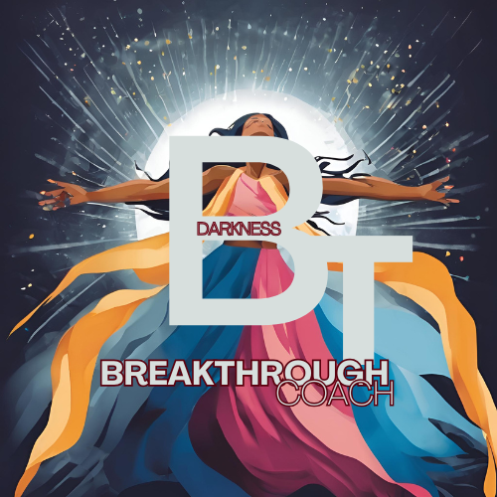

Breakthrough Darkness Program:

Step 3:

The Turning Point – Pivoting Toward Faith

Steps coming soon….