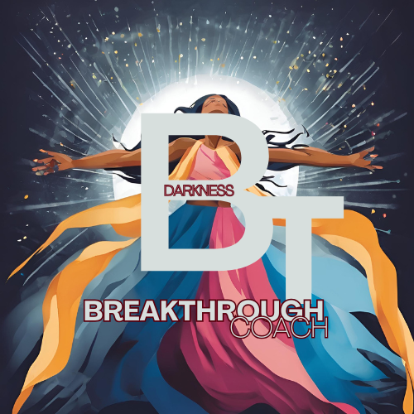

Breakthrough Darkness Program:

Steps coming soon….